Inventory Application

Development Project - Team 1

Members

Tara Talarico

Jessica Glickman

Conor Murphy

Nick Boss

Brendon Kang

Management of Technological Organizations

Professor Hughes

April 29, 2016

**Table of Contents**

**Topic Page**

Executive Summary 3

Introduction 4

Objective 4

Project Members 4-5

Communication and Collaboration 5-6

Project Plan 7

Financial Analysis 8-10

Development Process 10-12

Development 18

Research 18-19

Results 19-20

Summary Conclusion 21

**Executive Summary**

There are currently many small and medium sized restaurants that do not have an efficient inventory system. It was the goal of the project team to to capture this market of restaurant owners and provide them with an application that would manage their inventory in a easy and efficient way. This application will provide a less costly and easily accessible way for its clientele to replace outdated methods of inventory management, while providing updates to satisfy the clients.

The project team began working in the middle of January. The first meeting with the team was face to face with the purpose of determining each member’s skills and interests, which then followed up with brainstorming ideas for the project. The following meeting is where the team members were able to finalize on an idea that the team members wanted to work on: The Inventory Application and then began working on the scope, goals, and basic functionality of the application. When the scope and goals became clear, the team created a cost/benefit analysis where the costs for three years came to $165,822, but with exponential increase in revenue over the three years. A project plan was then created for the span of 13 weeks where each member of the team was delegated with various tasks and goals that had to be completed within a specific time frame. The team met up weekly with the client to give updates on progress, ideas, and answer any questions that is relevant to the future progress of the project.

The team was keeping to the project plan schedule, while making adjustments, and was starting to create the front end and back end of the application. The team was using Cloud9 to create and host the website and Amazon Relational Databases for the the database. After establishing the foundation of the application, the team developed diagrams and prototypes on how the application should be designed. Keeping simplicity in mind, the team created a prototype application consisting of a website with a home page containing information, price, and contact of the page along with a basic demo that allowed users to add in a product and managing that product. Upon completion of the prototype the team members went to find users to test the application and provide feedback/suggestions.

After gaining user feedback, the team sought to make improvements in their prototype by adding some new functions such as adding different storage spaces, restocking, and thresholds for products. Upon adding in new features, the team went out to find potential investors to help cover the costs of the application. The team is devoted to provide an affordable and efficient application that will help restaurant owners manage their inventory and will continue to add in additional features and updates to satisfy their clientele.

**Introduction**

Inventory Application is an mobile application that was created to assist small to medium sized restaurants reduce the time and effort it takes for an employee or manager to do inventory by hand. The purpose of this application is to make the inventory process easier as well as reduce the risk of error due to poor hand-writing and misunderstandings. Inventory Application allows business to automate their inventory process so that they can spend more time on other tasks.

Due to most members on this project having experience working in restaurants this application was important to create. The main deliverable for this project is a web and mobile application that provides an inventory management solution for small and medium restaurants. By using Inventory Application businesses will be able to spend less time and effort on inventory as well as save money that would be wasted due to mistakes.

**Objective**

The current process for doing inventory in small to medium sized businesses is done by hand and is extremely time consuming. Due to companies not having a centralized system or database to help with this process there is a large margin for mistakes when counting inventory by hand, writing down numbers on paper, then transferring the information from the paper to an order form on a computer. Our product, Inventory Application, seeks to solve this dilemma by providing an affordable and easy-to-use tracking and managing system for small to medium sized businesses that are currently slowed down by their current inventory process.

**Project Members**

The people behind the idea and development of Inventory Application includes:

**Tara Talarico**

* *Project Manager*
* Kept project on a time schedule
* Set objectives and goals for each week
* Managed People and Resources
* In charge of delegating tasks each week to members that needed to be accomplished

**Jessica Glickman**

*Research Developer*

* Directs research
* Ensured that all research is on task for the project at hand
* Oversaw scientific aspects of project
* Searched for and found relevant information on competitors
* Kept track of data and feedback received by client and test subjects

**Nicholas Boss**

*Documentation Manager*

* Managed the documentation of the group in accordance with organizational goals
* Developed standard documentation methods to effectively communicate product concepts and use
* Ensured any necessary internal process documentation.
* Wrote, reviewed, and edited documents to ensure that collaborated work flowed and was what the client wanted

**Conor Murphy**

*Full Stack Developer*

* Designed clean and intuitive user interfaces
* Designed application with security concerns in mind
* Designed front end and back end of application using knowledge of servers, networking, and web hosting
* Understood customer needs and implemented these into application

**Brendon Kang**

*Technology Developer*

* Programed the prototype of the application
* Understood and used user feedback the modify application
* Programed application to be as efficient as possible

**Communication and Collaboration**

**In Person Communication**

* General Face-to-Face Meetings
  + Purpose of meetings in-person were to discuss options on how to execute the project plan as well as practice presentations in order to be prepared for the client.
  + Meetings covered what work needed to be done that week, project due dates, and what was accomplished in the previous week(s).
  + Face-to-Face meetings allowed for in-person collaboration and brainstorming in a specific time frame where other methods of communication would have been more delayed and less productive.
  + Meeting date and times were scheduled through GroupMe, this allowed members to discuss the date, time, and place that worked best for them.
  + Project Manager was able to delegate tasks that needed to be accomplished.
  + Documentation Manager took notes and uploaded the key points of meetings to GoogleDrive so members could look at what was discussed.

**Tools Used for Communication**

* Email
  + Used to send important documents, agendas, and minutes to team members as well as the client.
* Google Drive
  + Main tool used for collaboration on documents.
  + Used to share important documents and information with all members.
  + Allowed all members to collaborate and comment on documents and presentations for the client.
  + Helped store all documents in one folders for easy access.
* Google Hangouts
  + Used as an alternative to face-to-face team meetings when members were unable to be in the same place at one time.
  + Allowed members to talk in real-time to plan how to execute the project plan.
  + Was the best alternative to face-to-face meetings due to messages not being seen in GroupMe.
* GroupMe
  + Tool was used for constant communication between team members
  + A messaging application that allows users to have access on their phone or computer.
  + Allows users to create events for face-to-face meetings and also set reminders at different times leading up to the event to ensure that members did not forget.
  + Allowed members to share ideas, ask questions, and give status reports of their work when needed.
  + Was the best messaging option due to GroupMe storing all messages so members had the ability to go back and look for specific information that was posted previously.

**Project Plan**

To begin Stage 1 of this project, the team had multiple meetings in which they decided the roles which the members would take on for the remainder of the project as well as the general idea of the project itself. The team held a kickoff meeting where they developed the concept and scope of the project, communicated via GroupMe to come up with a name that best suited our project, and collaborated through Google docs and an in-person meeting to develop the proposal. This initial communication was vital and carried into Stage 2 of the project where the team would plan the activities and research that would set the framework for the rest of the project. They planned the dates for their meetings as well as their agenda, and executed both software research for the application and general research to determine what problems they would tackle through the application. The team then finally put together a report detailing what exactly their application would to, as well as how they would be communicating effectively, a cost benefit analysis, and a gantt chart outlining their project plan.

In Stage 3, the team developed their prototype application first using low, medium, and high fidelity mock-ups before creating their final layout using HTML and CSS through a Cloud 9 workspace. Upon completion of their front-end development, they moved on to the back-end development which included inputting a user system, designing a database for the inventory information, and creating the systems architecture and software engineering. The members then all tested the application and made changes accordingly based on their findings. Upon completing the prototype, they submitted their development document, created a powerpoint for the in class presentation, and updated the gantt chart.

Stage 4 was all about getting user feedback from the restaurants that the team chose to work with. They spoke to Chart House, Rumson Country Club, Tacoria,, Little Tokyo, and Tenderhill. To begin this stage, they created surveys based on what information the team wanted to get back that would best help in making sure the application performed with exceptional efficiency for the users. They then distributed the surveys and compiled all of the information that was gathered. From there, changes were made to fix the bugs in accordance to what was mentioned in the surveys. Upon completing the final prototype of the application, the team revised the system requirements and prepared for their final presentation.

Finally, Stage 5 and 6 were last stages and consisted of submitting the final report, evaluations of the group members, and participating in the management showcase to show off their application and what it does.

**Financial Analysis**

**Introduction**

The application is intended to bring a cost efficient solution to small independent restaurants for easing the burden of the manual inventory process. While the application provides extensive features that benefit these types of businesses, the team decided the best cost was to charge for a monthly subscription of $15/month. The team believes this is the most attractive looking cost as well as a price that will benefit their endeavor the most as it will bring in a substantial income while working at a competitive pricing. Most inventory management software ranges from $400-$1000+. This pricing combined with a simple yet effect software solution should appear to the target audience as the most lucrative choice for their inventory needs.

**Cost Calculations**

There are very minor complications in cost for developing this product. The team is small and well equipped team in terms of skill, there are no costs for hiring outside workers and the result of a product includes an intuitive interface that allows anyone to easily manage inventory databases, reducing the costs of training to those who buy the product. Nearly all of the tools used to develop the product are free and available to everyone. These include programming languages and operating systems. While there a multitude of minor costs, such as domain hosting and employee salaries, the main costs for developing this product comes from database hosting. The team decided to use Amazon Relational Database services for database needs which totals out to $12,200/year. On top of this, they will be using a MySQL license that totals to $10,000/year. They will also be purchasing a large backup storage database at an initial cost of $41,000 and $8,000/year for maintenance.

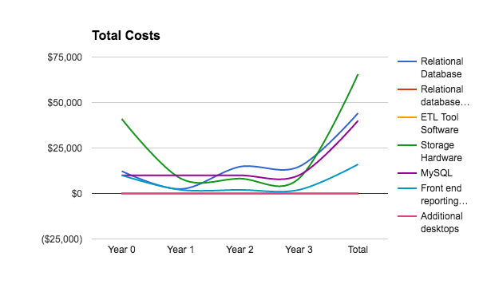

**Competitive Advantage**

As mentioned prior, the application is intended to bring a cost efficient inventory management solution to small independent restaurants. The failure rate for restaurants is high (60%) and an expensive inventory management application may not be a concern for a smaller restaurant that is trying to find stability in the market. However, this does not change that fact that inventory management remains a burden as chefs attempt to balance the concentration on producing great food for customers and taking the time to handle necessary business logistics. This is where the team believe that their product can succeed in gaining a stronghold in the restaurant market. In the U.S., there are approximately 340,135 independent restaurants and the team expects to be able to sell to at least 40% of these restaurants. Our easy-to-use, affordable, and beneficial application would be a perfect application for smaller restaurants to invest in, especially at an affordable monthly price which customers may choose to opt out of whenever they desire.

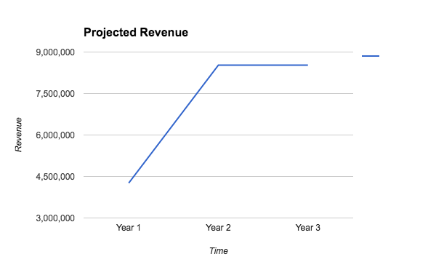

**Analysis**

Small independent restaurants face a high risk of failure due to troubles with accounting, management, and food quality. Several of the members have experience in restaurants and know from firsthand experience that the manual process of inventory tracking is a burden on chefs and their ability to fully commit to their task of producing great food products. At the same time, owners of these smaller restaurants will doubtfully be interested in an expensive product that takes a length of time to learn just to manage the inventory that their chefs are already doing as a standard part of their job. The inventory app is the perfect innovation for this market, as it is low cost and has a simple learning curve. The application will be enticing to restaurant owners when they see the simple application improving the jobs of their accounts and chefs.

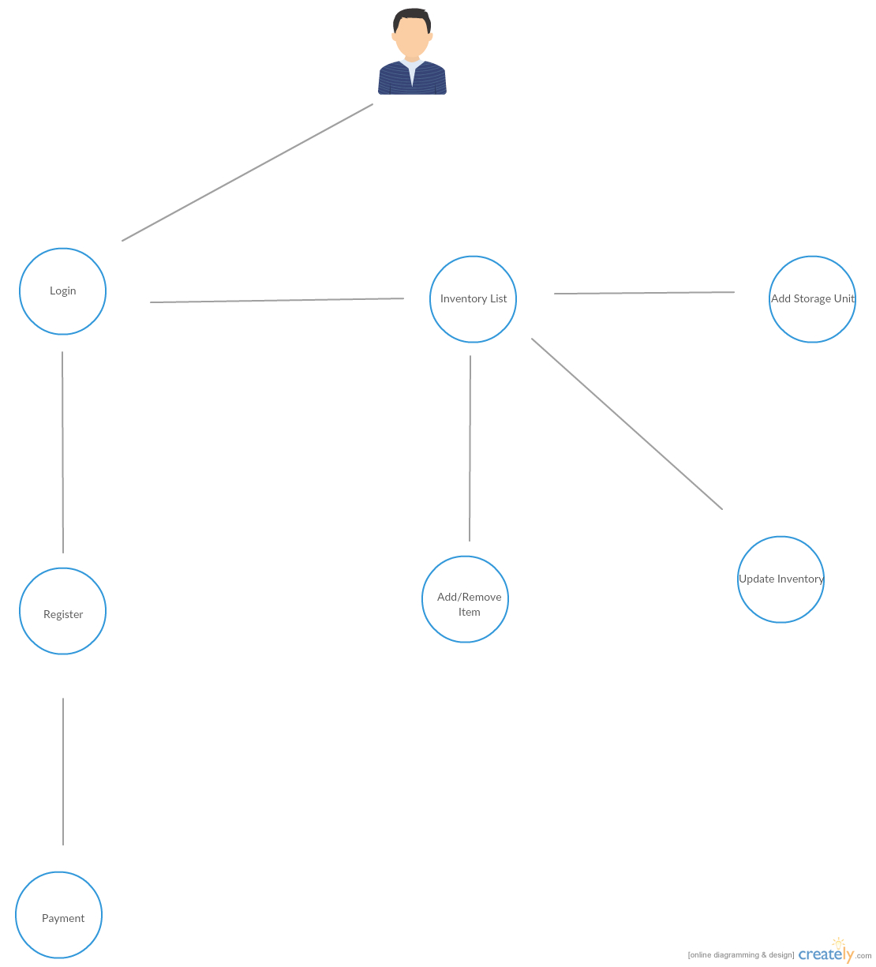

**Development Process**

**Front and back end development**

The application is intended to be used on tablet devices, it was important to be critical about which technologies used to achieve the goal. While tablet and mobile specific apps are easily accessible and specifically designed for their respective mediums, it became apparent to the team’s developers that taking an app specific approach would only limit them in design and product accessibility. To develop an application for both OS X and Android devices, different types of code would have to have been implemented. So instead it was determined that the best approach would be to create a web application tailored to tablet style devices. Web 2.0 is the obvious solution as its technologies translate across all platforms. Thus, the frontend solution consisted of HTML5, CSS and CSS3 components for the design/stylization, and Javascript and its JQuery library for user interface interaction, interaction between the frontend and backend (using AJAX), and DOM manipulation. JQuery was the essential component in designing the user interface. The library made it easy to turn each part of the web application into an interactive component that interacted with the inventory database. A prime example is the main inventory page. JQuery allowed it so that a user may interact with HTML components, such as add/subtract icons, which perform essential functions such as adding to the count of an inventory item or vice versa. The goal was to create a clean and interactive/responsive user interface. JQuery combined with Bootstrap made this a very real possibility.

The backend of the application uses Linux, Apache, MySQL, and PHP (LAMP stack). The choice for each is very clear - Linux is a great and secure development environment at no cost. Likewise, Apache is a great free web server that is used universally and constantly maintained by a large community of contributors. This means that bugs are constantly fixed and identified, an important part of product uptime and safety. Finally, PHP is an obvious choice when working with the backend of web applications. While there are other popular backend languages to use, such as Ruby on Rails, the team has the most experience with PHP and so it made the most sense to use. Initially the programming style took a procedural approach in order to interact with the database and retrieve information. However, as the application grew more complex, it made sense to reorganize the code into an Object Oriented style which made the code, development, and our application more efficient. PHP was a suitable choice to pass information back and forth from the database to the frontend for the user.

In the future, the application developers plan on redeveloping the application using modern Javascript frameworks such as AngularJS. While JQuery has served their needs, the code could be better and the structure of our application more efficient. AngularJS provides a more logical approach to designing the frontend of web applications, as you must think about how the application will be structured rather than how you will manipulate a pre-existing structure, and allows for a more responsive and interactive design for the user - which is what the team cares about the most. A great example of this responsive web design, and inspiration in the design of our application, is the product called Timely.

**Database**

The database is the most important aspect of our application as it serves as the functionality of the restaurant’s inventory. Therefore, the design and implementation were equally important. The first table created was the Customers table which is used to store data for every user who purchases our product. This includes their account ID, payment information, and data to refer back to their specific inventory needs. Following this there is an inventory table which holds each product and its specific inventory location of that restaurant. After this, there is a location table which stores the various location names of storage units for each specific customer's restaurant. Finally, there is an orders table which stores the current order request for each customer to their preferred distributors.

**UI Design, Components, and Goals**

The UI design implemented into the application is meant to deliver a simple and intuitive experience to users. On the main web page, the team used a single page that contains all of the information you may need about the product. This type of format allowed for smoother and more appealing methods of navigating the website, such as automatic scrolling to desired sections of the web page. In the application itself, the team used Bootstrap glyphicons in order to provide simple yet telling icons that show you how to act accordingly with the application. The goal was to achieve a responsive and interactive web application that looks crisp and clean - Bootstrap and JQuery was essential in achieving this.

**Requirements**

Software requirements:

* Languages: PHP
* DBMS: MySQL
* OS: Fedora Linux

Development requirements:

* Cloud9 as an IDE
* Github for source control

UI Requirements:

* HTML5 and CSS for the structure and layout of the website and application
* Javascript(JQuery) to make the UI functional and dynamic

Functional Requirements:

* Users database system for customers
* An inventory control panel to display each inventory and manage its product
* An inventory preferences page to add and manage new inventory locations, products, and ordering guidelines

Client Requirements:

As stressed in this paper, the goal of the product is to provide small restaurants with a simple to use, yet efficient inventory management application. It is essential that the functional requirements of the application were developed in a manner that would allow the customer to easily manage their own inventory database without any confusion or need for training.

**Design methods**

**Use Case Diagrams (System and Client)**

**Customer Use Case Diagram**

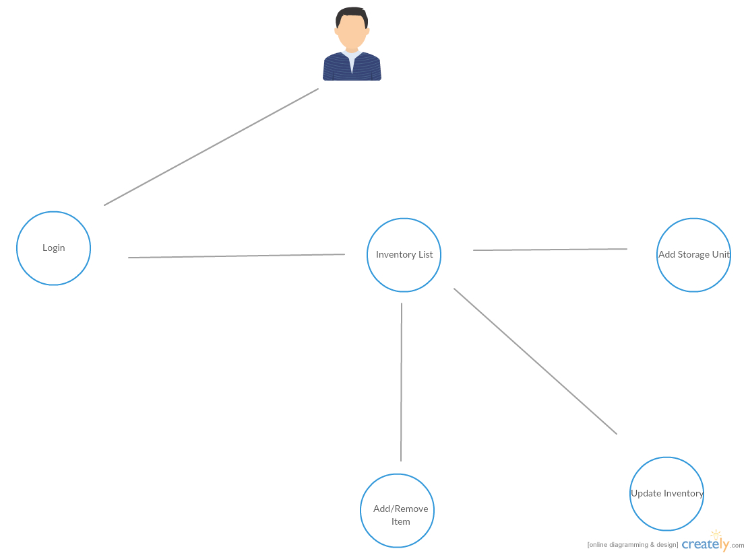

This use case describes the actions a customer can take after logging in to their account. The customer can manage their inventory along with adding and removing additional items and storage units.

**Site Map**

Initial site map to determine essential site content

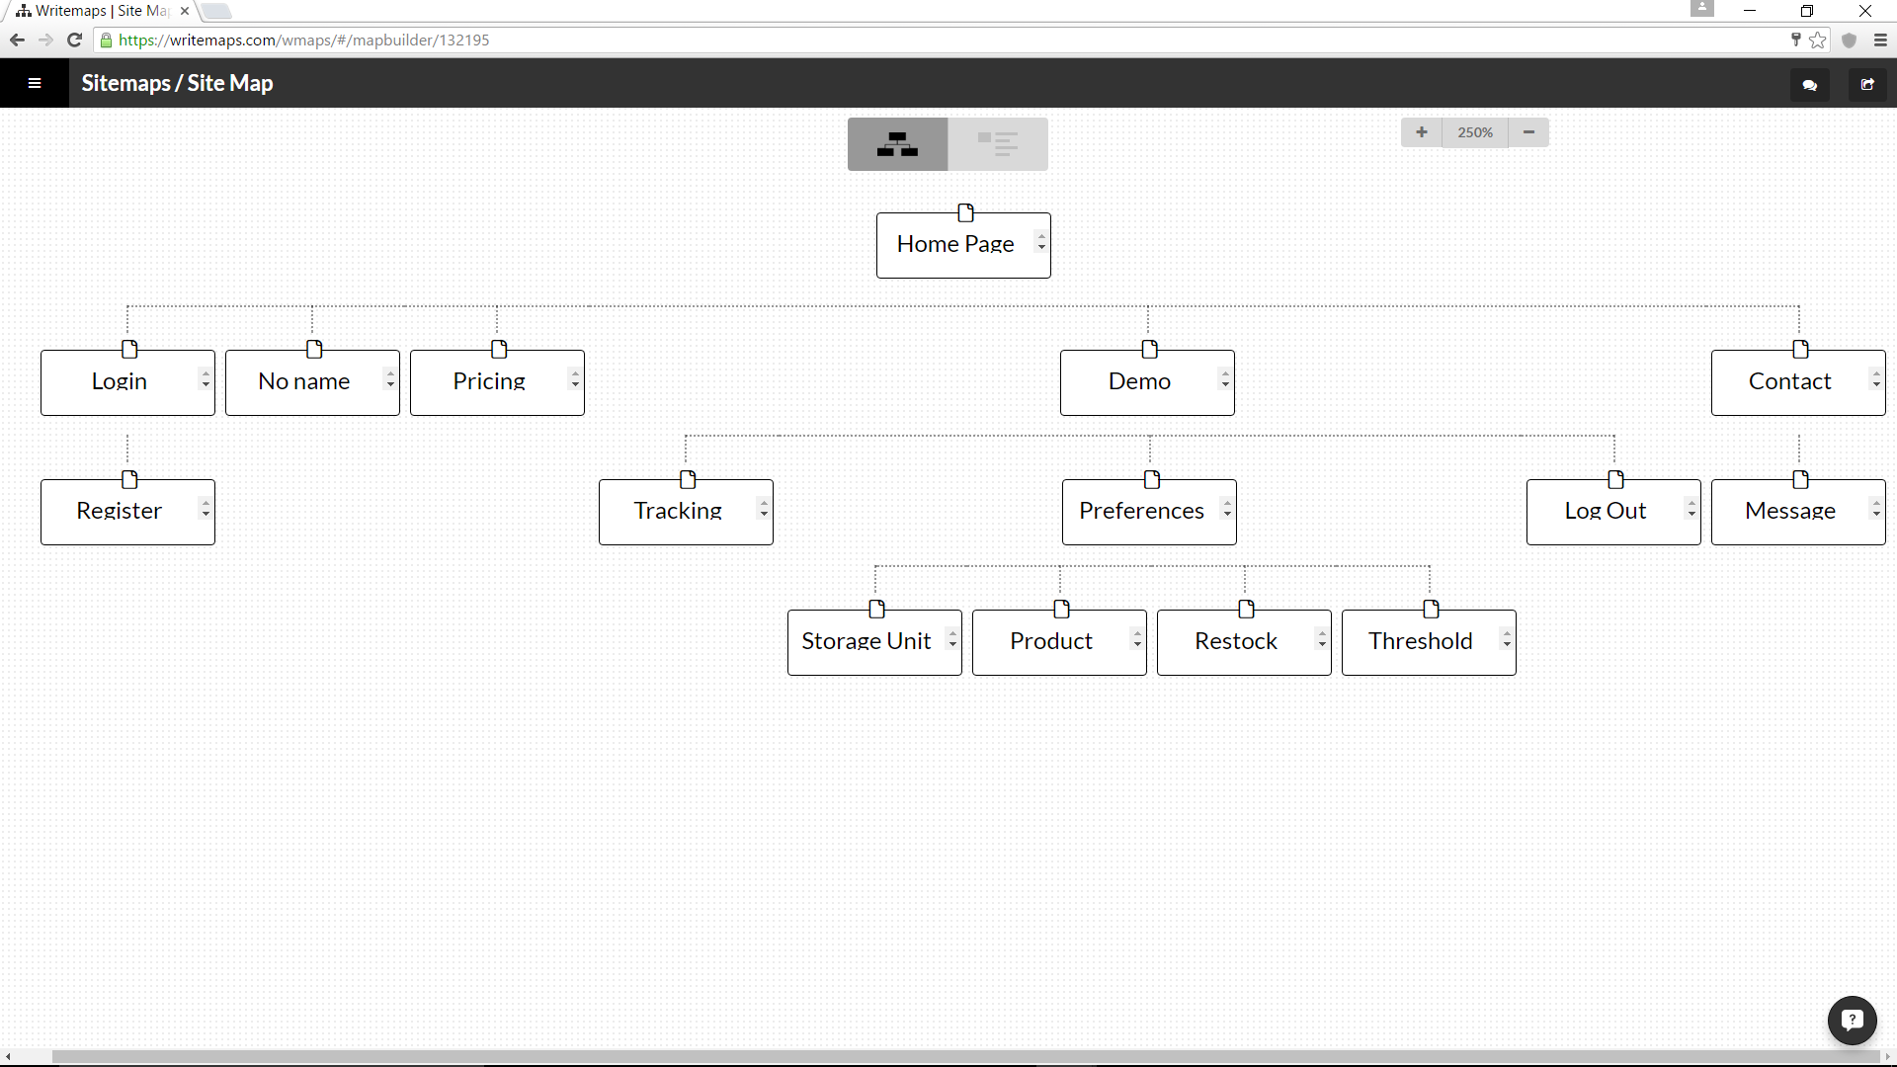

**Activity Diagram**

Details and choices that users can make when using the demo.

Untitled Diagram.png

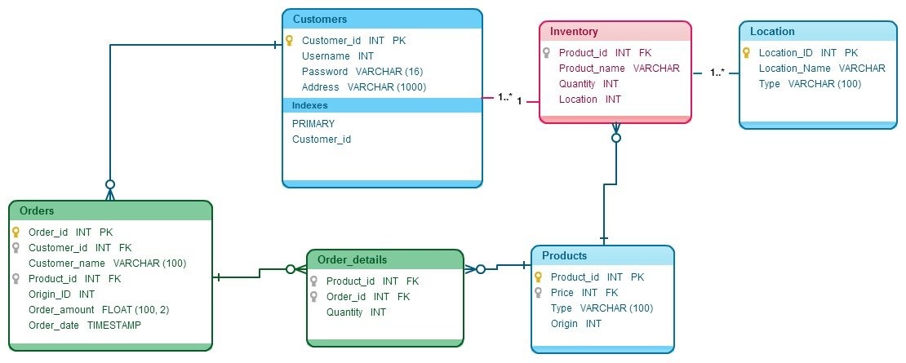

Database Prototype

Untitled Diagram (1).png

Integration Diagram

**Development**

**Prototype**

For the team’s inventory service they believed that a web application would be best for potential clients. By utilizing cloud9 as the base for designing the web application allows clients to access it across all platforms. Using JQuery for the prototype gave clients the major functionality of an inventory application system, but the team has decided to switch over in the future to AngularJS, which not only would allow the team to give more advanced features that clients have wanted to see, but also more suited for updating and maintaining a web application. The team chose a layout that was very simple and easy to use by having all of the pages linked to the main menu bar at the top. After the client logs in the layout of the application itself is kept in line and orderly, while also giving all functionality in a separate main menu bar for registered users.

The website consists of a home page with the about, pricing, and contact on the home page with a main menu bar that brings the user down to the section when clicked on. Users can send a message to the team with the contact section at the bottom of the home page. In addition there is a demo and login button in the main menu bar, which allows user to first test a demo of the application before registering. When users are testing out the demo they will be redirected to another page where it consists of three two pages- Track and Preferences.Track is where the user can keep track of their inventory within each storage unit along with managing the amount. Preferences redirects the user to another page that allows the user to add in additional objects such as storage unit, product, restock, and threshold for items.

**Research**

In order for the team to accomplish their end goal of creating an inventory application that was successful for their intended audiences of small restaurants, they needed to conduct research. First, the team discussed potential connections to small restaurants, and which local businesses would be useful test subjects. The team decided that Rumson Country Club, Chart House, Tender Hill, Little Tokyo, and Tacoria would be useful test subjects. As a team, they discussed the key points that would help them not only satisfy, but impress their potential customers with their application. From there, the team developed a list of questions to ask the restaurants. The potential clients were asked to evaluate The Inventory Application based on its ease of use, how it would improve their current inventory process, and its appearance. They were also asked if they would like to see any features added to the current version of the application.

Overall, the feedback that the team received was positive. Almost all of the potential clients wanted a feature that would allow the application to communicate with Microsoft Excel. This would be useful in order to track when items would need to be ordered, from which supplier, and help manage their finances. They also requested that prices be shown for each item and total price of the current inventory be available. All but one of the clients said that they would prefer a subscription based service versus a one time initial fee. Lastly, all of the potential clients thought that the application is easy to use and would make their current inventory process more efficient.

**Results**

<https://inventoryapp-cjm322.c9users.io/index.html>

The project has been completed as planned and a demonstrational web application is ready to take to clients. The completed application can be used on the desktop and mobile devices such as phones and tablets. All the devices have access to the homepage and demo of the application.

The team used a variety of communication applications in order to keep in contact with one another. The team used mainly GroupMe for day to day contact, keep everyone updated on what needs to be done, and plan meetings in person. For the weekly team meetings the team used Google Hangouts to ask more specific questions and discuss in detail about what each member has done for the week and what will need to be done in the following week. The team decided to use Google applications such as docs and slides for all documentation and presentation materials, which allowed the entire team to edit and add in materials.

The team decided to create an web application, but as the project went on the team decided that the application be available on tablets. After various prototypes and updates were made, the team decided to bring the product to various clients for user testing to receive feedback. The team was glad to see that the majority of users found the application very simple and easy to use, and found it very easy to integrate into their businesses. The feedback was very informative as clients requested to see some additional features such as pricing of products, exporting/importing spreadsheets of the products, and a function that will automatically deduct ingredients used to create a certain dish. The team decided to switch to AngularJS from JQuery in the future to be able to expand to accommodate clients’ requests and for overall better web application development.

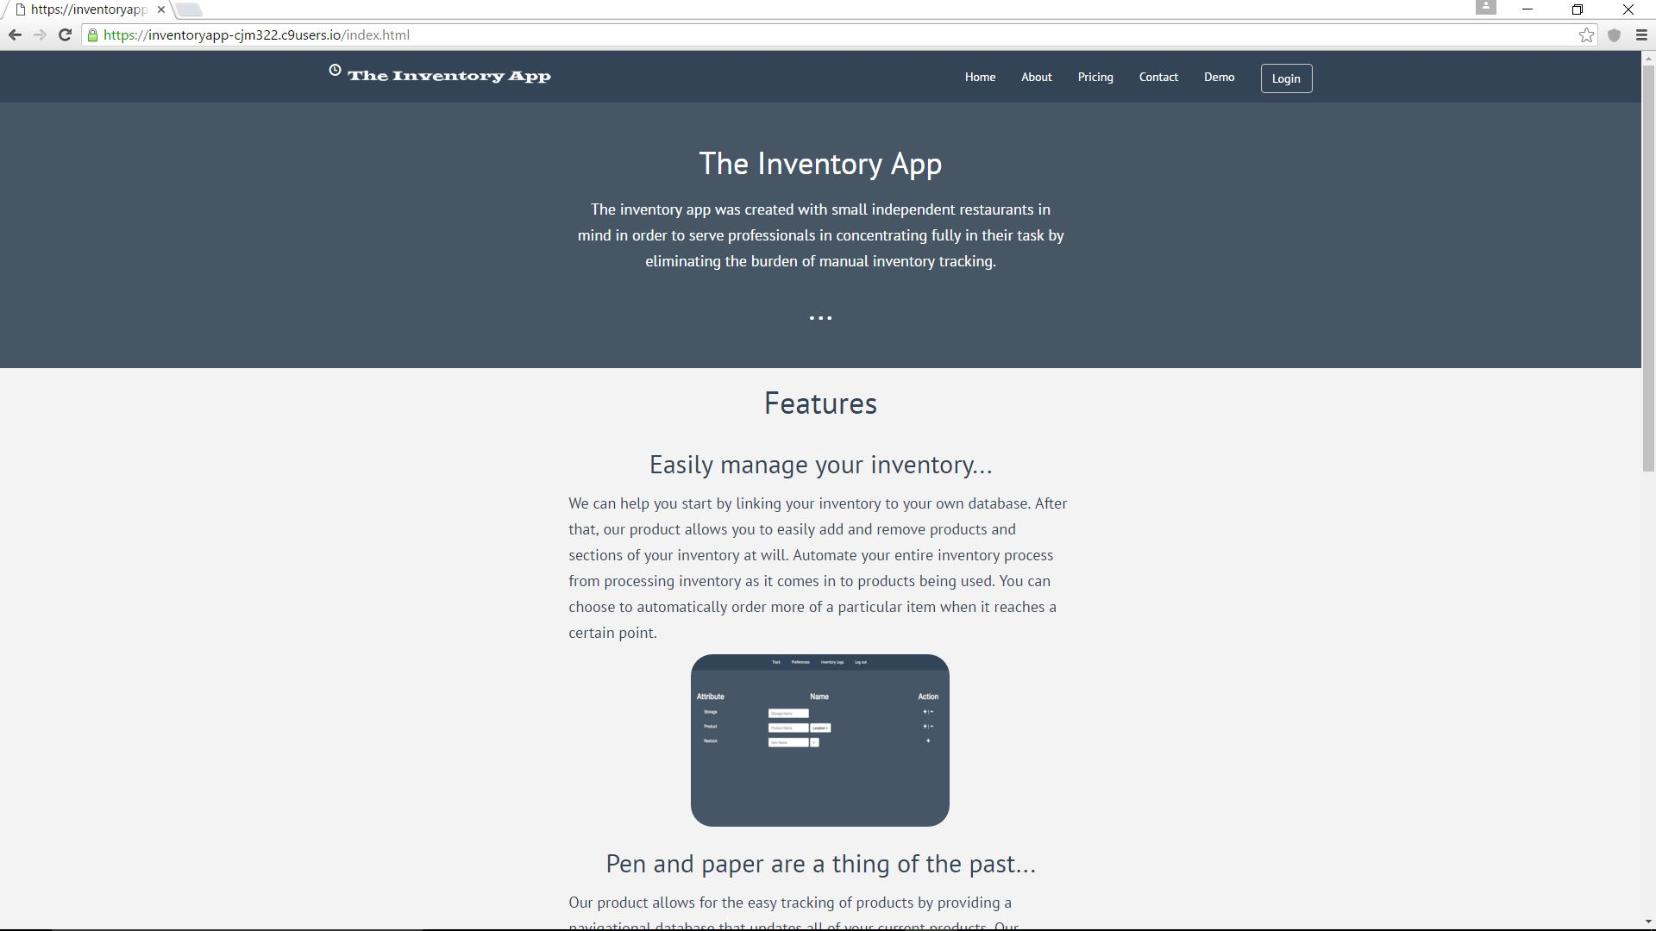

View of Home Page on computer.

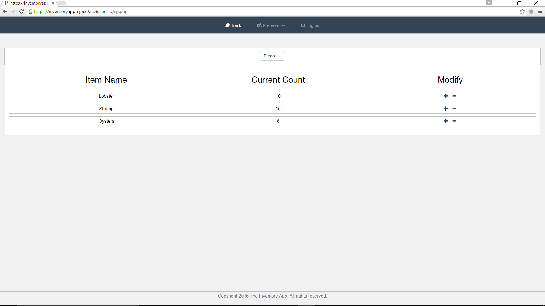

View of the main page of the demo.

**Source Code**

<https://github.com/C-J-Murphy/inventoryapp>

**Summary Conclusion**

The Inventory Application is an application designed to act as a inventory management system for small to medium sized restaurant owners. While many inventory applications do exist, the Inventory Application is one that is very simple, affordable, and easy to integrate into businesses. Inventory management is crucial to restaurants and the Inventory Application allows an efficient way for owners to manage it.

The Inventory Application differentiates itself from competitors by being inexpensive and using a subscription based fee. The design of the application was kept simple and doesn’t involve complex software and programming languages (using free and open source development tools) allowing the team to create a very affordable price for small restaurants. Most applications are license based and clients would have to purchase updates from time to time, but by being subscription based will allow all clients to receive updates regularly without additional costs. This design allows the Inventory Application to be very persuading to many small and medium sized restaurant owners, which would allow investors to gain exponential returns on their investments.

The experience of this project: planning, organizing, developing, creating, pitching, was a very valuable and unforgettable journey for the project team and the team thanks Professor Hughes for all the guidance given throughout the project.